Case Number QA 05111E

Page 1 of 14
Adjudicator’s Decision
Appellant A
and
Hertfordshire County Council
Penalty Charge Notice QA XXX £60.00

Appeal allowed on the ground that the alleged contravention did not occur.

I direct the Council to cancel the Penalty Charge Notice.

Summary

1. The traffic regulation order only restricts traffic other than buses and taxis entering and driving westwards along Moor End Road from the Waterhouse Street roundabout. The traffic order does not have the effect of restricting traffic travelling from the direction of Leighton Buzzard Road in an eastbound direction.

2. Vehicles travelling from Leighton Buzzard Road to Waterhouse Street are not contravening any traffic order.

3. While there may have been a breach of the traffic order restricting traffic other than buses and taxis from entering and travelling westwards along Moor End Road from Waterhouse Street, the restriction is unenforceable because Hertfordshire County Council have failed in their duty under Regulation 18 of the Local Authorities' Traffic Orders (Procedure) (England
and Wales) Regulations 1996 reasonably to bring the effect of the order to the attention of road users

4. Although not forming part of the judgment in Appellant A’s case, since I find that the TRO does not prohibit traffic travelling eastwards it follows that the signs at Bus link are unlawfully placed, and, and in any event my findings as to the use of the wrong signs in relation to the westbound restriction would apply.

Reasons

1. Appellant A’s PCN is dated 1 September 2011 and was issued by post in
respect of a contravention on 22 August 2011 at 16:13 relating to vehicle XXXX in Moor End Road for being in a bus lane.

2. Appellant B’s PCN is dated 1 September 2011 and was issued by post in
respect of a contravention on 25 August 2011 at 14:02 relating to vehicle
XXXX in Moor End Road for being in a bus lane.

Page 2 of 14

3. With the consent of the parties I have consolidated the appeals of Appellant A (Traffic Penalty Tribunal case QA05111E) and Appellant B (Traffic Penalty Tribunal case QA05275B). They did not know of one another before these proceedings. The reason for this was that Appellant A had been issued with a penalty charge notice for ‘being in a bus lane’ when they drove their car eastbound along Moor End Road towards Waterhouse Street, and Appellant B had been issued with a penalty charge notice for ‘being in a bus lane’ when driving their car westbound in Moor End Road from Waterhouse Street towards Leighton Buzzard Road.

4. Initially there was a telephone hearing of their appeals in which both appellants participated, as did Mr Twigg, officer of Hertfordshire County Council (“Herts CC”) who deals with appeals. During that hearing I informed the parties that, coincidentally, I had a pre-arranged appointment in Hemel Hempstead that afternoon, therefore I would be able to visit the site. I invited the parties to attend. Both Appellant B and Appellant A agreed to meet me at the site; Mr Twigg could not alter his arrangements but he said that the two officers of Herts CC were in any event going to the site later in the afternoon to take photographs. When I met Appellant A and Appellant B I was accompanied by an independent witness to the conversations that took place.

5. The hearing was reconvened on 7 February 2012 when I conducted a telephone hearing with the following participants:
Appellant A - appellant
Appellant B - appellant
Mr Twigg - Herts CC Appeals Manager
Mr Ogbomaya Herts CC Legal Department
Mr Sturridge - Herts CC the operational side
Mr Curtis - Herts CC who drafted the traffic order
Councillor Hollinghurst Dacorum Borough Council

Background

6. Appellant A and Appellant B were each sent a penalty charge notice by post from HCC for “being in a bus lane” in Moor End Road, Hemel Hempstead. The PCNs did not specify in which direction either Appellant A’s or Appellant B’s vehicle was travelling, but it is not in dispute that Appellant A was travelling eastwards,coming from the direction of Leighton Buzzard Road, and Appellant B was driving westwards, having come down Waterhouse Street.

Page 3 of 14

7. The penalty charge that Herts CC is seeking to impose in each case is £60,which could have been settled by paying the reduced penalty charge of £30 had either Appellant A or Appellant B decided to do so. They did not. They objected to paying the penalty because they did not consider they should penalised for a contravention that they had no idea they had committed until they each received a PCN

The Location

8. According to Herts CC the 50 metres of Moor End Road subject to these two PCNs has been restricted to traffic other than buses, taxis and authorised vehicles for many years, but had not for some time been subject to police enforcement. Therefore Herts CC decided to adopt the civil enforcement of bus lane powers introduced by The Bus Lane Contraventions (Penalty Charges, Adjudication and Enforcement) (England) Regulations 2005, made under
Section 144 of the Transport Act 2000. They also issued a new traffic regulation order relating to Moor End Road.

10. Section 144(4) of the Transport Act 2000 describes a bus lane contravention:

(4 ) A bus lane contravention is a contravention of any such provision of—

(a) a traffic regulation order…

as relates to the use of an area of road which is or forms part of a bus lane.

(5) And an area of road is or forms part of a bus lane if the order provides that it may be used—

(a) only by buses (or a particular description of bus), or

(b) only by buses (or a particular description of bus) and some other class

or classes of vehicular traffic.

Therefore there must be a contravention of the terms of a traffic order creating a bus lane to justify the imposition of a penalty charge.

The Traffic Regulation Order

Page 4 of 14

11. The Traffic Regulation Order (“TRO”) that Herts CC introduced when they
decided to enforce the Moor End Road bus route was the Hertfordshire (Moor
End Road, Hemel Hempstead) (Prohibition of Driving Motor Vehicles Except Buses and Taxis) Order 2010 (“The 2010 TRO”). This Order revoked the earlier 2006 Order that had previously been in force.
Article 2 states:

No person shall cause or permit any motor vehicle except a bus or taxi to enter and drive along that length of Moor End Road, Hemel Hempstead from its junction with Waterhouse Street westwards to its junction with New Bus Link a distance of approximately 50 metres

12.. Giving this sentence its grammatical meaning, it clearly creates a restriction prohibiting vehicles from entering and driving westwards along the 50 metre stretch of Moor End Road measured from the junction of Waterhouse Street to the junction with New Bus Link. The grammatical meaning of Article 2 does not prohibit vehicles driving eastwards along the same stretch of Moor End Road.

13. The Council suggests that Article 2 can be read with a meaning to the effect that vehicles are prohibited from entering and driving along the 50 metres stretch of Moor End Road, measured from its junction with Waterhouse Street westward to the junction with Bus Link. They say that Article 2 creates a restriction eastbound as well as westbound.

14. It is the use of the word “westwards” that creates problems for Herts CC. The Oxford Online Dictionary makes it clear that while the word “westward” can be both an adjective and an adverb, the word “westwards” can only be an adverb:

“westward -

adjective

●   towards the west: the journey covers eight time zones in a westward direction

adverb

●   (also westwards) in a westerly direction: a track leads westwards through the glen”

In Article 2 the only verbs (other than cause or permit) are “enter” and “drive” and the adverb “westwards” can only relate to “enter and drive”. Furthermore the OED describes “along” as:

“preposition & adverb - moving in a constant direction on (a more or less horizontal surface):

●   [as preposition]: soon we were driving along a narrow road, he saw Gray run along the top of the wall

Page 5 of 14

●   [as adverb]: we continued to plod along”

Article 2 uses “along” as a preposition shown in the OED first example – combined with the verb ‘to drive’, thereby describing the motion of the vehicle in a constant direction; consequently “westwards” not only relates to “drive”, but also to “drive along”.

15. Therefore the only meaning that can be attached to Article 2 is that the prohibition relates to a vehicle other than a bus or taxi entering and “driving along westwards” along Moor End Road from its junction with Waterhouse Street.

I6. In fact, the description “westwards” is unnecessary – Moor End Road does not continue eastward from the junction with Waterhouse Street and straight ahead at the roundabout is a loading area for the shops.

17. The use of westward, eastward etc is only necessary where the length of road is measured from a cross-roads or a T junction. For example at the crossroads of High Street and Market Road, the order would need to state “the northern side of the High Street from the junction with Market Street westward for 100 metres” - an entirely different area of road would be restricted if applied to the northern side of High Street from its junction with Market Street eastward for 100 metres.

18. Herts CC referred me to other examples of TRO drafting which they considered illustrated the style of drafting used in Article 2 of the 2010 Order. In particular they refer to this example from Plymouth:

Schedule No. 212.10 (Reserved Bus Lane at Any Time)
Road Circulatory Bus Link Road Description Circulatory Bus Link Road from its
junction with the A386 Tavistock Road
eastwards for a distance of 50 metres.

I would observe that in this example, using apparently similar drafting, the area of restricted road is described in a phrase contained in a Schedule listing the lengths of road that are subject to the provisions that will have been set out in an Article in the main body of the TRO. The Article will be expressed in a sentence stating what should or may not be done in the lengths of road listed in the Schedule. The use of the adverb “eastwards” is incorrect, “eastward” used as an adjective being grammatically correct, however, because the description is a phrase with no verb the meaning has not been distorted.

Page 6 of 14

19. But this is not the case with Article 2 that incorporates the restricted length of road in the article comprising a single sentence.

20. I note that in the statutory notice of the making of the 2010 TRO the
restriction is described differently, namely in a schedule without reference to
“westwards”. It does not accurately describe the terms of the TRO:

Had the traffic order itself been drafted in those terms, ideally with the description of the relevant section of Moor End Road described in a schedule, as Plymouth City Council did with their TRO, then Herts CC would not be in the difficulties they find themselves.

21. Furthermore it must be born in mind that construing Article 2 only arises in the context of the imposition by Herts CC of a penalty upon Appellant A. Bennion on Statutory Interpretation (5th edition Page 48) states “It is a principle of legal policy that a person should not be penalised except under clear law.” It seems to me that Herts CC are striving to do just that – penalise people who drive eastwards in Moor End Road for contravening a statutory provision to which Herts CC attach a wholly unclear interpretation contrary to its grammatical meaning.

22. The effect of Article 2 is that there is no prohibition of any vehicles driving along Moor End Road eastwards to Waterhouse Street. Appellant A was perfectly at liberty to drive along the full length of Moor End Road, as they did, and no contravention occurred.

Page 7 of 14

23. It follows that Appellant A’s appeal is allowed and they are not liable to pay the penalty charge.

The Signs

24. Regulation 18(1) of the Local Authorities' Traffic Orders (Procedure)
(England and Wales) Regulations 1996 sets out the duty of a highways authority
to sign the provisions of a TRO:

Traffic signs

18.—(1) Where an order relating to any road has been made, the order making authority shall take such steps as are necessary to secure—

(a) before the order comes into force, the placing on or near the road of such traffic signs in such positions as the order making authority may consider requisite for securing that adequate information as to the effect of the order is made available to persons using the road;

(b) the maintenance of such signs for so long as the order remains
in force; and

(c) in a case where the order revokes, amends or alters the application of a previous order, the removal or replacement of existing traffic signs as the authority considers requisite to avoid confusion to road users by signs being left in the wrong positions.

25. In R(Oxfordshire County Council) v The Bus Lane Adjudicator [2010]
EWHC 894 (Admin) Mr Justice Beatson confirmed that,
“the fact that signs are prescribed or authorised does not mean they are sufficient for securing adequate information as to the effect of an order is made available to road users is clearly correct. If the signs do not in fact provide adequate information no offence is committed” [para. 65]

26. He went on to set out the matters to be considered when deciding whether the signs provided adequate information at the time of the alleged contravention,
“Where the signs have not been placed in positions where they cannot be seen or easily seen, are not obscured by vegetation or other street furniture, and are clearly visible and comply with Departmental Guidance, there must be strong reasons given for concluding that they do not provide adequate information” [para. 69]

Page 8 of 14

27. Put another way, the “Beatson Tests” comprise the following questions:

1. Are the signs themselves authorised in the Traffic Signs Regulations and General Directions 2002?

2. Are they placed in accordance with Department for Transport guidance set out in the Traffic Signs Manual?

3. Are the signs clearly visible and can easily be seen?

4. Are the signs obscured by vegetation or other street furniture?

28. If the answer to each of these questions is “yes”, then an adjudicator would have to provide strong reasons for finding that the signs did not adequately convey the affect of the traffic order to road users. In my view, the answers to the tests as whole need to be considered as a proportional mix, depending on the facts of the appeal before the adjudicator.

Applying the Beatson Tests to Moor End Road

29. Test 1 – Are the signs authorised by TSRGD?

The signs are authorised by diagram 619 of TSRGD, therefore Test 1 is satisfied.

30. Test 2 - Are they placed in accordance with Department for Transport guidance set out in the Traffic Signs Manual (TSM)?

While the signs are authorised signs in TSRGD, they are not the signs advised in
Chapter 3 of the TSM.

31. The Oxfordshire County Council case, in which Beatson J expounded the test related to a bus gate in Oxford High Street, where traffic, except local buses and the authorised vehicles, was restricted in the day time, but not at night. The bus gate was signed, as is Moor End Road, with sign 619, the prohibited traffic sign (colloquially known as the low-flying motor cycle):
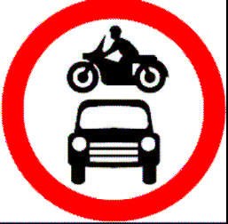
The bus lane adjudicator (myself, as it happens) questioned the use of sign 619 for a bus gate. In rejecting my finding that it was not the appropriate sign for the bus gate, Beatson J helpfully explained that the adjudicator must,
“take into account the signage's conformity to the Department's formal guidance set out in Chapter 3 of the Traffic Signs Manual. That specifically states that Diagram 619 should be used for bus lanes "where access to premises is required for other vehicles or where the bus lane does not apply at all times". The introduction to Chapter 3 states that "should" indicates a course of action "that is strongly recommended and represents good practice"[para 68].

Page 9 of 14

32. Sign 619 is not the one recommended in Chapter 3 of the TSM for use at an “at any time” bus only street or bus gate. This is because the Moor End Road prohibition applies at all times, and therefore while the prohibited traffic sign (diagram 619) is an authorised sign in TSRGD, Herts CC has not followed the signing regime for a bus gate strongly recommended in Chapter 3 of TSM - contrary to good practice.

33. Paragraph 15.4 of Chapter 3 of the Traffic Signs Manual reads:

“15.4 Bus-only streets and bus gates are lengths of road or parts of a road where access is restricted to buses, although sometimes other vehicles such as pedal cycles, taxis and trams are also admitted.”

Paragraph 15.29 indicates that “Where either a one-way or two-way road is
reserved for buses and cycles, the entry points should be indicated by signs to
diagram 953.
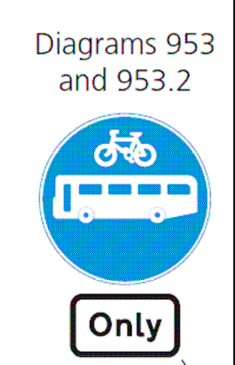
The paragraph goes on to explain that the prohibited traffic sign 619 should be used where the bus-only restriction does not apply at all times or access is required (both of which were the case in the bus gate in Oxford High Street).Neither condition applies in Moor End Road.

34. Therefore, DfT guidance in Chapter 3 of the TSM states that the signs that should be used are diagram 953 of TSRGD, with the cycle omitted and substituted with the word “taxi”. The sign should also be accompanied by the road marking at diagrams 1048.3 and 1048.4

Page 10 of 14

35. Section 15 contains a helpful layout of a bus gate with the signs and marking that should be used:
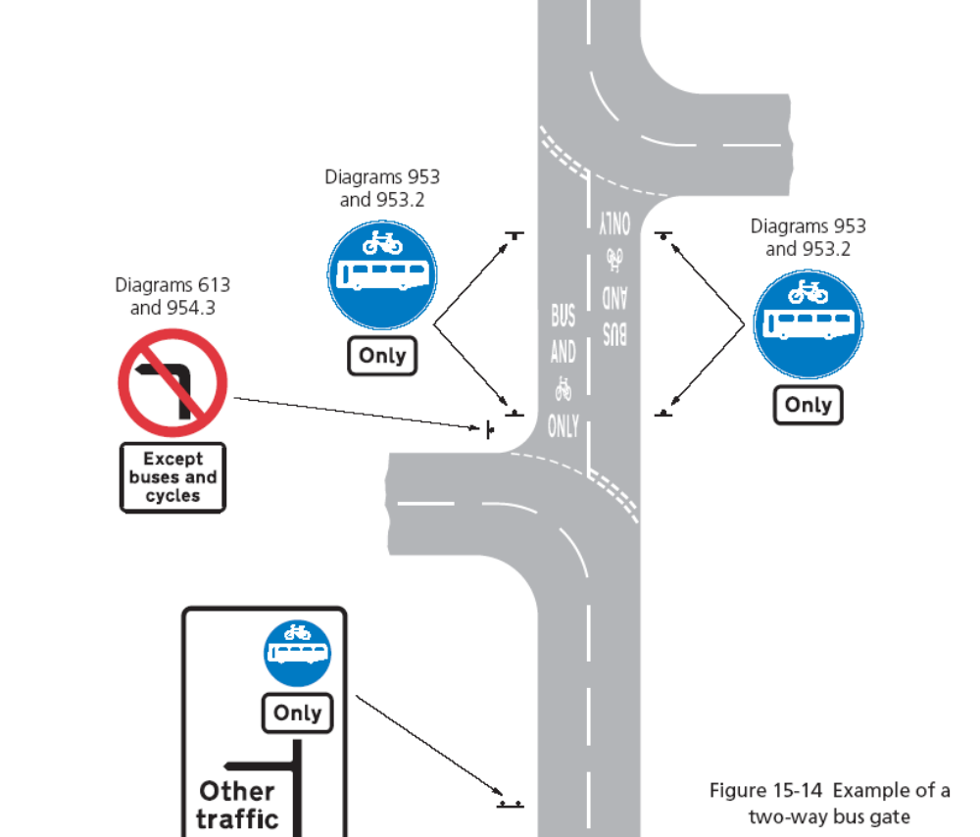

36. When Appellant B drove along Moor End Road there were no road markings but, because of the number of PCNs that had been issued, and the complaints about the signs, Herts CC decided to add road markings (which are not associated with diagram 619). A sensible plan was produced by the engineering department placing the road marking at the entry to the restricted area of Moor End Road, However, when they came to be painted, it was decided to position the road markings beyond the zebra crossing, right in the middle of the 15 metre restricted stretch, thereby only visible to traffic that had already entered the area. In fact, at the site visit we saw a van drive into Moor End Road from the roundabout, and when the driver saw the road marking, he decided to reverse back (Mr Twigg said that happens frequently).

37. Therefore, even though there are now road markings (which are not strictly applicable to these two appeals) they are not positioned so as to be either correct or effective.

38. Taken as a whole, I find as a fact that Herts CC failed to follow the DfT
Guidance, 619 not being the signs that should be used for an “at any time” bus
gate. In those circumstances the conditions of Beatson Test 2 are not satisfied.

Page 11 of 14

39. Test 3 - Are the signs clearly visible and easily be seen?

I find as a fact that neither sign at the Waterhouse St Roundabout is clearly visible and easily seen.
Looking at the Herts CC photograph it can readily be seen that:

●The offside/right sign cannot be seen at all when approaching Moor End
Road from the roundabout; and

●  the nearside/left sign is not facing head on and is excessively high

40. I am bound to comment with regard to the photograph that, first, it is taken from a view that a driver coming round the roundabout would not see, and secondly, the brightness of the sign (and the council officer’s high visibility jacket) in the photo may have been enhanced the photo-reflective coating of the sign. Therefore the prominence of the sign in the photo may not represent the visibility to a driver in daylight without head lights.

41. The sign is placed at a curious angle, presumably intended to be seen by vehicles approaching down Waterhouse Street. However, the effect of the angle is to make it less likely to be seen if the driver has not spotted it coming down Waterhouse Street (for example, if buses are stopped to allow pedestrians to cross) and arrives at the junction round the roundabout.

42. Because the offside/right sign is completely out of sight Herts CC cannot rely on that sign to indicate to drivers coming round the roundabout that Moor End Road is restricted.

Page 12 of 14

43. Concerning the height of the 619 roundel on the nearside sign, after the second telephone hearing Appellant A measured the height of the diagram 619 section of the sign from the kerb stone and it was 2.68 metres above the footway, so the sign will be over 2.70 metres above the carriageway.

44. The recommended heights for mounting signs is addressed at Paragraph 1.49 in Chapter One of the Traffic Signs Manual [2004 – DfT] in the section that deals with “Positioning of Signs”:
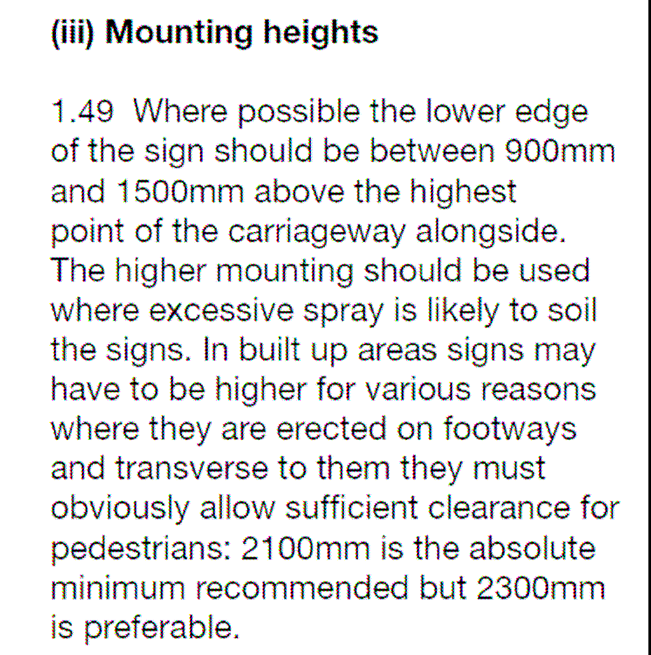
I appreciate that the signs are mounted to allow for pedestrians but 2700 mm is too high for displaying the principal, regulatory 619 roundel, particularly given that the driver is approaching from round a roundabout. Furthermore, the driver is likely to be concentrating on the zebra crossing and pedestrians and might not glance several degrees to the left (the Traffic Signs Manual advises that a driver should not have to avert his or her eyes more that 10 degrees to see and take in a sign).

45. I therefore find that the nearside/left sign is placed so it is not clearly
visible and easy to be seen for many drivers approaching from Waterhouse
Street.

46. I find that both signs in Waterhouse Street fail the Beatson Test 3.

47. Test 4 - Are the signs obscured by vegetation or other street furniture?

The answer to this question is “Yes”.

Page 13 of 14

48. The Herts CC’s photographs show how the right/offside sign is obscured from view to a vehicle coming down Waterhouse Street by the local amenities signpost. As we have seen above, it is also too far to the right, and facing away from vehicles coming round the roundabout, to whose drivers it is completely invisible.

49. These findings support Appellant B’s assertion with his appeal:
“there is strong evidence that the signage is neither clear (unless there are over 25,000+ poorly sighted motorists in Hemel Hempstead) nor is it correct.”

50. I agree with his contention, and find that Herts CC have failed to bring to the attention of the road users the effect of the order restricting traffic except buses and taxis from driving into and westwards along Moor End Road.

51. In R (Herron) v the Parking Adjudicator ( 2011 EWCA Civ 905) Lord Justice
Stanley Burnton confirmed that, “It has long been recognised that the
enforceability of a TRO requires that adequate notice of the applicable restriction
is given to the road user. The principle is derived from Regulation 18 of the Local
Authorities' Traffic Orders (Procedure) (England and Wales) Regulations 1996”.

52. It follows that the only valid restriction on the 50 metres of Moor End
Road, namely the westbound restriction, is rendered unenforceable due to Herts
CC’s failure to comply with Regulation 18.

Page 14 of 14

53. For those reasons Appellant B’s appeal is allowed.

54. I am aware that in a number of appeals appellants have criticised the signs in Moor End Road for vehicles travelling eastwards. I have found that there is no restriction in that direction and it follows from that finding that the signs in Moor End Road are not lawfully placed. I would nevertheless observe that my findings in relation to the Beatson Test 2, namely that the signs 619 are not the ones that should be used for a 24.7 bus gate would apply. Furthermore, the bus lane adjudicator Mr Knapp commented in an earlier case that the nearside sign is obscured by a lamp post, which would mean that signs placed at Bus Link, if the eastbound were lane restricted, would also fail the Beatson Tests 3 and 4.

55. Finally, I understand that the DfT has now authorised the use of the ‘No Entry’ sign at this restriction, and so my comments about the use of signs 619 and 930, may not be relevant to the future.

Caroline Sheppard

Adjudicator 30 March 2012

